Rocket MW Code
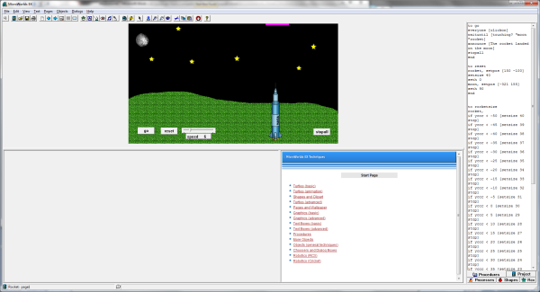
to go
everyone [clickon]
waituntil [touching? "moon "rocket]
announce [The rocket landed on the moon]
stopall
end

to reset
rocket, setpos [150 -100]
setsize 40
seth 0
moon, setpos [-321 155]
seth 90
end

to rocketsize
rocket,
if ycor < -50 [setsize 40 stop]
if ycor < -45 [setsize 39 stop]
if ycor < -40 [setsize 38 stop]
if ycor < -35 [setsize 37 stop]
if ycor < -30 [setsize 36 stop]
if ycor < -25 [setsize 35 stop]
if ycor < -20 [setsize 34 stop]
if ycor < -15 [setsize 33 stop]
if ycor < -10 [setsize 32 stop]
if ycor < -5 [setsize 31 stop]
if ycor < 0 [setsize 30 stop]
if ycor < 5 [setsize 29 stop]
if ycor < 10 [setsize 28 stop]
if ycor < 15 [setsize 27 stop]
if ycor < 20 [setsize 26 stop]
if ycor < 25 [setsize 25 stop]
if ycor < 30 [setsize 24 stop]
if ycor < 35 [setsize 23 stop]
if ycor < 40 [setsize 22 stop]
if ycor < 45 [setsize 21 stop]
if ycor < 50 [setsize 20 stop]
if ycor < 55 [setsize 19 stop]
if ycor < 60 [setsize 18 stop]
if ycor < 65 [setsize 17 stop]
if ycor < 70 [setsize 16 stop]
if ycor < 75 [setsize 15 stop]
if ycor < 80 [setsize 14 stop]
if ycor < 85 [setsize 13 stop]
if ycor < 95 [setsize 12 stop]
if ycor < 100 [setsize 11 stop]
setsize 10
end

